Dear Editor,
I am submitting a research manuscript, entitled ‘Residual correlation shows that European earwigs do not trade off clutch and egg size’ for consideration as an original contribution in Current Zoology.
The trade-off between egg number and size is widely accepted in evolutionary biology. However, many studies fail to find this relationship. This failure results from researchers correlating egg number and size for one clutch across several females. This approach does not consider the variation among females in resource acquisition. A more effective method is to measure egg number and size across multiple clutches per female and to calculate the residual correlation using a mixed-model approach.

I hereby confirm that my submitted manuscript contains no overlap with other articles published, in press, or in preparation, and that the material contained in my manuscript has not been published or submitted elsewhere.

Should you have any further questions or require additional information, please do not hesitate to contact me. I look forward to your decision in due course.

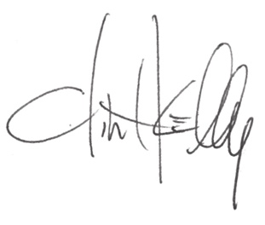

Clint Kelly

